19162121031

SMIT R PATEL

SEM 5

PRACTICAL 16

BIG DATA AND ANALYTICS

AIM- To understand the working of SPSS Modeller in Watson Studio.

Exercise: Vodafone wants to analyse the factors as to why their customers are disassociating with

their company and churning out. They have a few data files in order to help understand the

same. Use a tool in the IBM Cloud in order to create a model to get insights and obtain

graphs to understand the results better.

Tasks:

1. Upload the data files in your Watson Studio Instance.

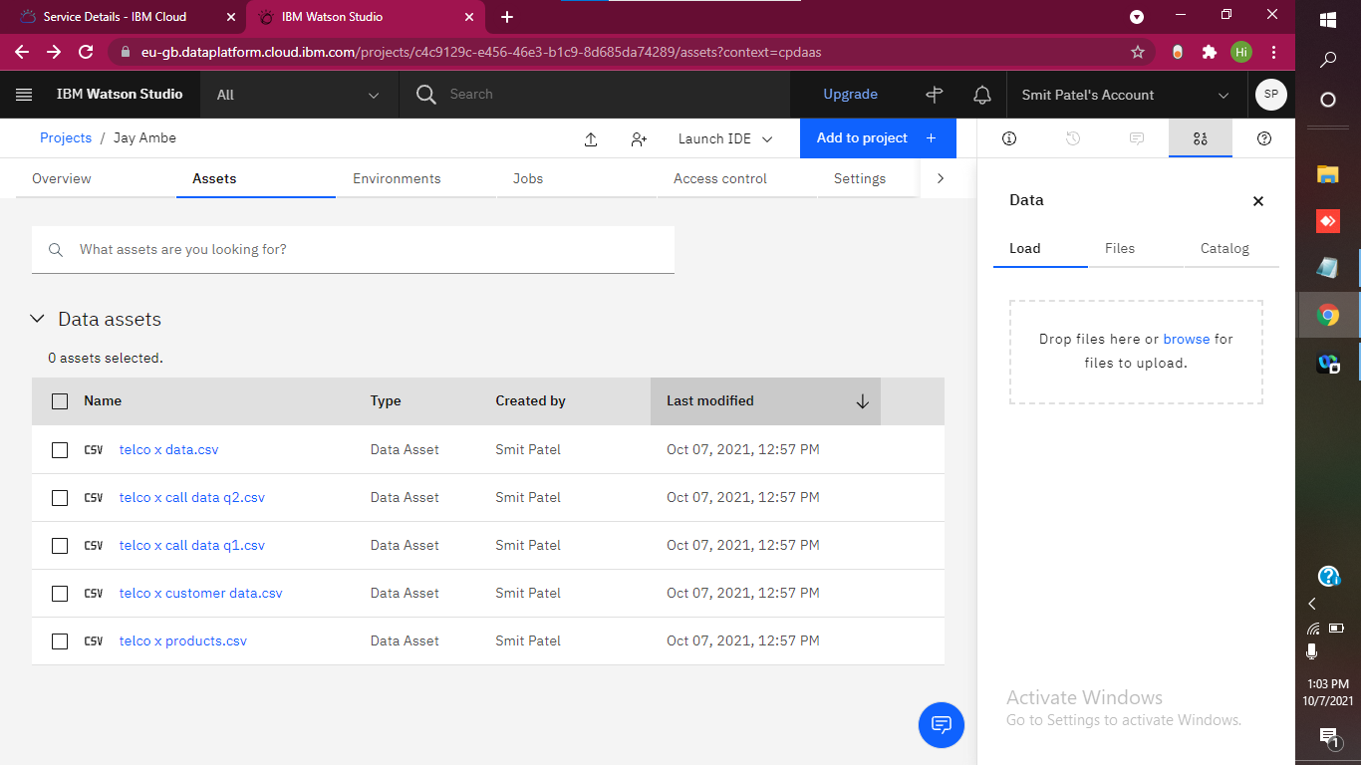

2. Understand basics of SPSS and a modeller flow.

🡪 SPSS stands for **Statistical Package for the Social Sciences**

🡪 IBM Watson SPSS Modeler flows in Watson Studio provide an interactive environment for quickly building machine learning pipelines that **flow data from ingestion to transformation to model building and evaluation**, without needing any code.

🡪 SPSS Modeler provides data mining and text analysis software, while SPSS Statistics is an integrated family of products. Both tools enable users **to build predictive models** and execute other analytics tasks.Modeler can apply different processes and algorithms to help the user discover information hidden in the data

🡪 **IBM SPSS Statistics** (2010) The new official name is now IBM SPSS Statistics and is part of IBM's analytics portfolio

3. Create an appropriate SPSS modeller flow to obtain the result.

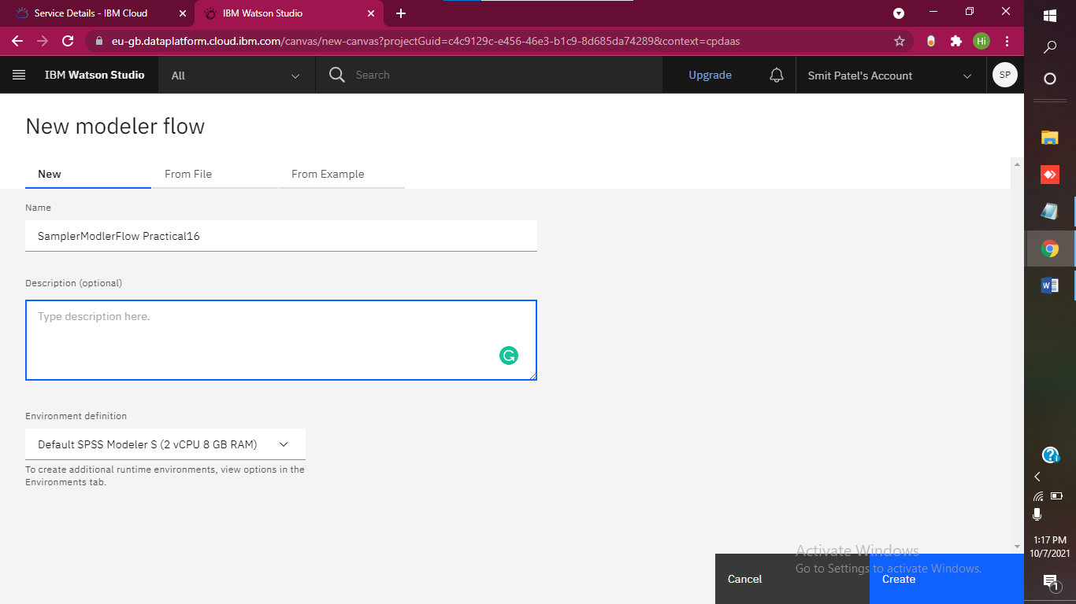

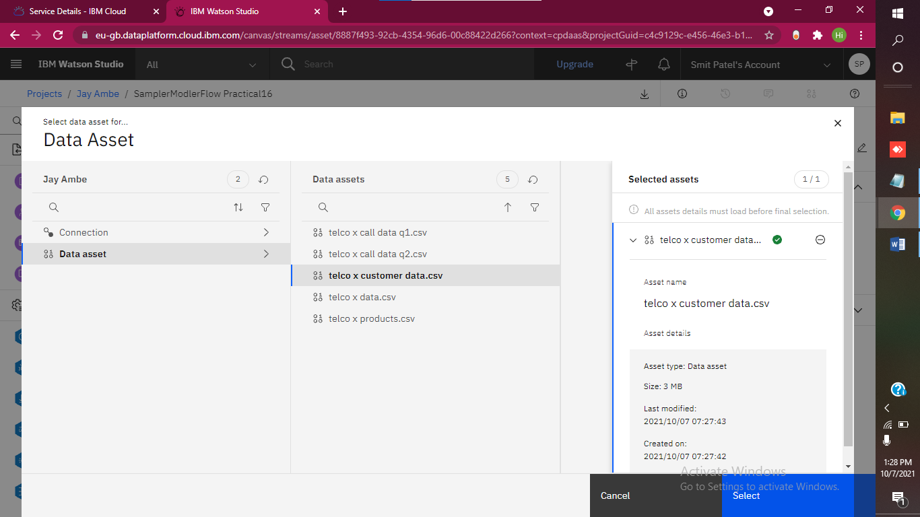

4. Add graph nodes to depict results in the form of Graphs.

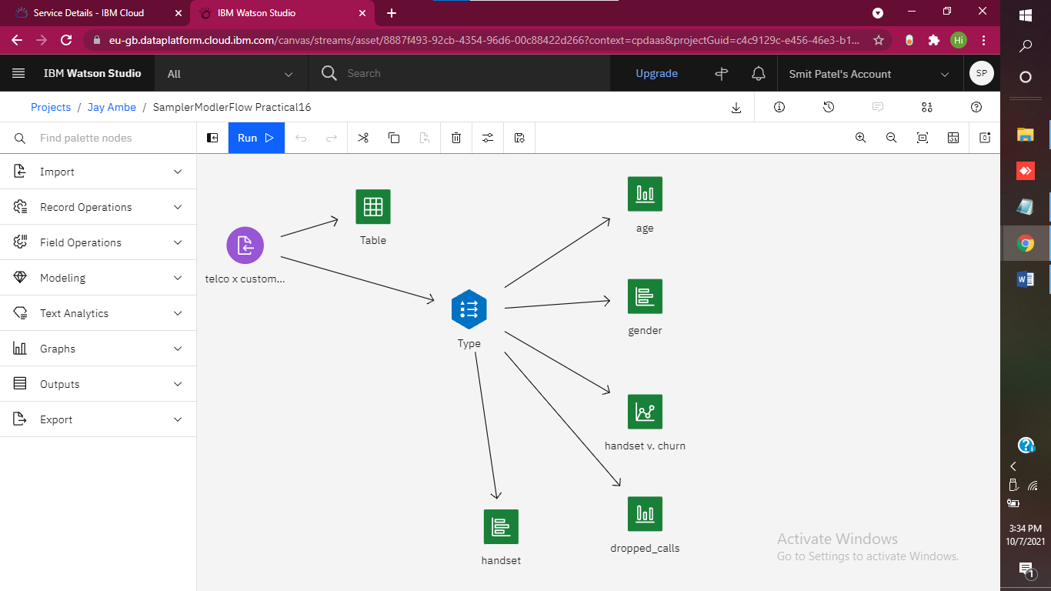

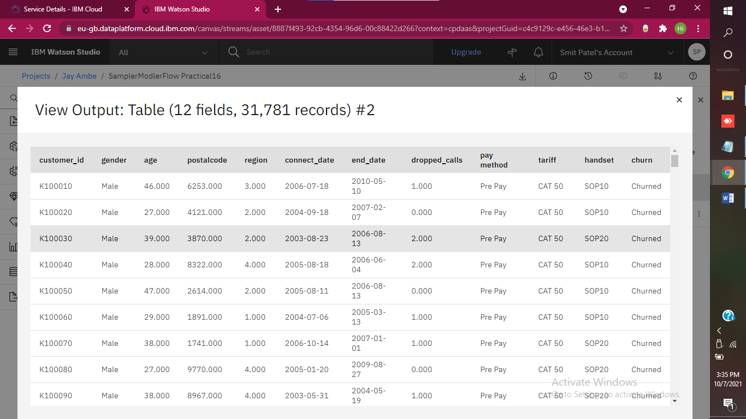

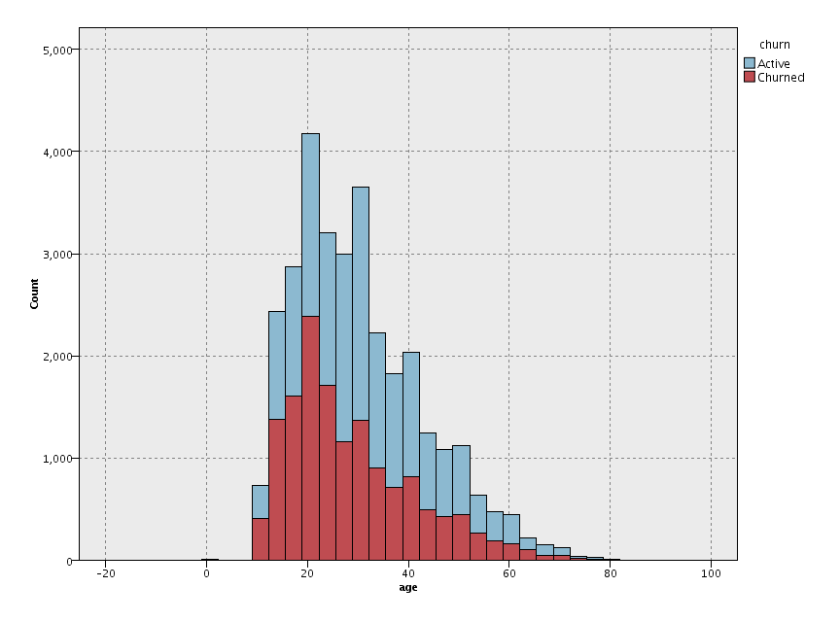

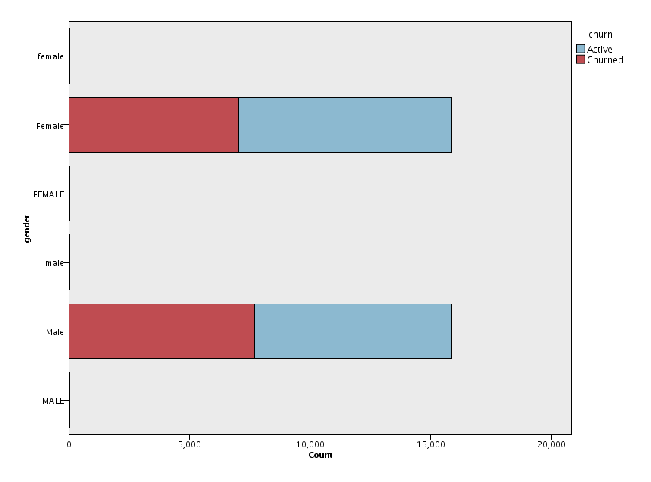

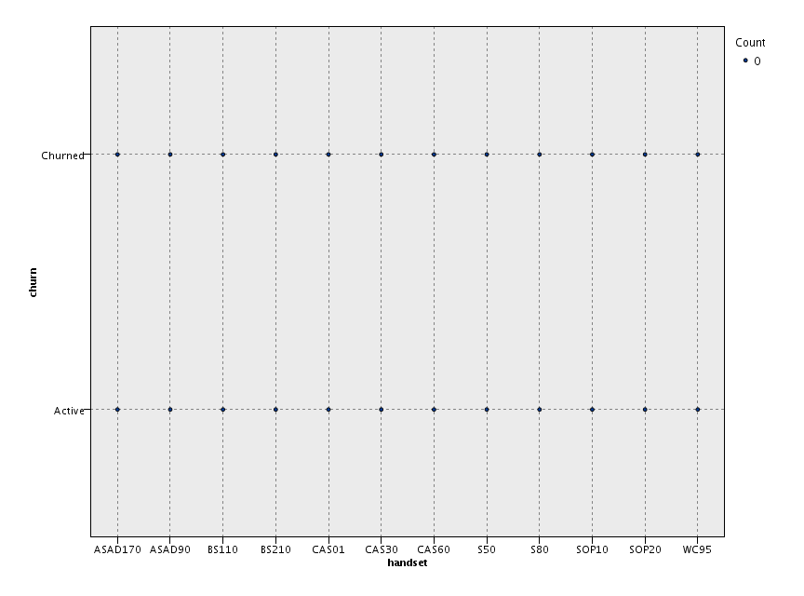

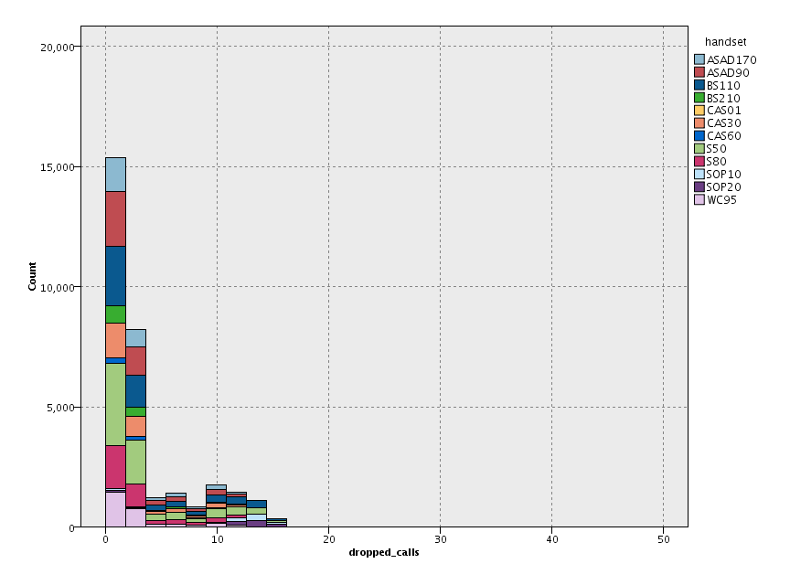

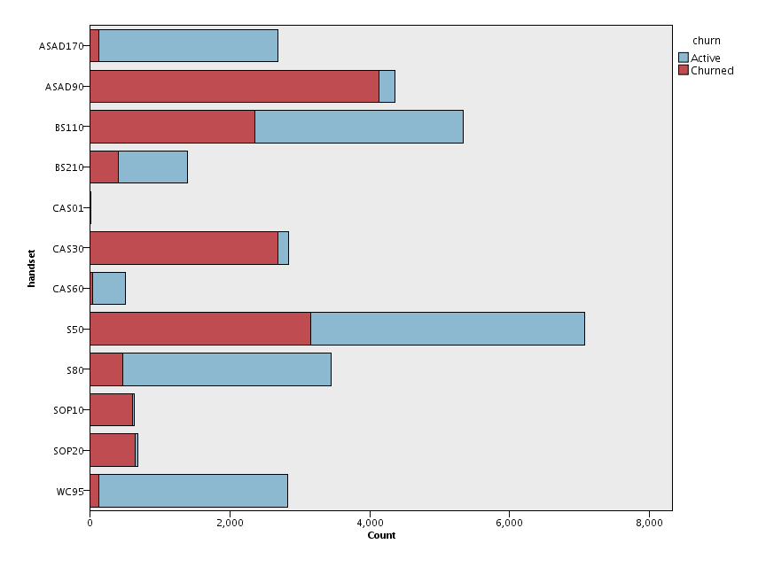

Extra :-

Now We get telco x data.csv file for practice more in Watson studio

